**Week 09**

# **TASK 1:**

**Goal 1:**

Function: Protection

Category: A

Sub-category: 1

Reason: The purpose is to safeguard the project's critical assets by preventing unauthorized access to sensitive data and systems.

Result: This helps mitigate the risks associated with poor authentication systems or insufficient access restrictions.

**Goal 2:**

Function: Protection

Category: B

Sub-category: 2

Reason: Ensuring the accuracy and consistency of project data is crucial, aiming to maintain data integrity.

Result: This helps reduce the risks associated with data tampering or unauthorized alterations.

**Goal 3:**

Function: Detection

Category: C

Sub-category: 3

Reason: Rapidly detecting cybersecurity incidents and occurrences enables prompt response and minimizes their impact on the project.

Result: This helps mitigate the risks associated with failing to identify unauthorized access attempts or potential malware infections.

**Goal 4:**

Function: Detection

Category: D

Sub-category: 4

Reason: Proactively identifying security breaches in the project through continuous monitoring and analysis of security procedures.

Result: This helps reduce the risks associated with insider threats, unusual network behavior, or unauthorized access attempts.

# **TASK 2:**

The inventory should encompass all categories of assets and include specific identifying details for each item. Data assets should be classified based on their value or level of access, and important safeguards such as confidentiality, integrity, and availability (CIA) should be mentioned. Here is an example of how the asset inventory can be structured using tables for each asset category.

**Data Assets:**

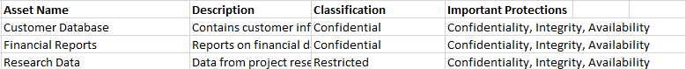

**Hardware Assets:**

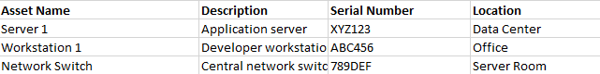

**Software Assets:**

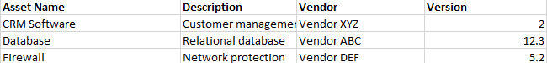

**Network Assets:**

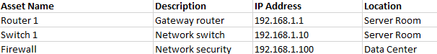

**Personnel Assets:**

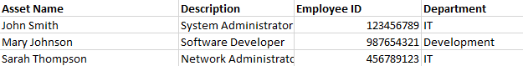

**Physical Assets:**

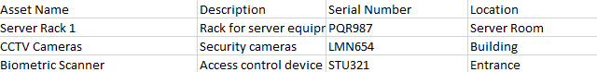

# **TASK 3:**

Information flow diagram depicting the data flow for the two most significant data assets identified in Task 1. The diagram illustrates the connections between these data assets and all other assets within the inventory. This visualization enhances the accuracy of the asset inventory and facilitates the identification of any potential errors. Here is an example of how to represent the information flows:

Diagram showcasing the flow of information for the Customer Database.

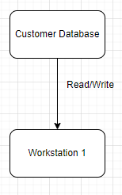

Information Flow Diagram for Financial Reports:

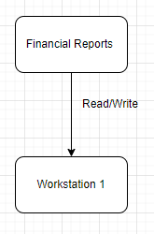

The diagrams employ rectangular shapes to represent the data assets, such as customer databases and financial reports. Arrows indicate the direction of information flow between the data assets and their associated assets, such as Workstation 1.

By comparing these information flow diagrams with your asset inventory, you can ensure the accuracy of the connections between the data assets and other assets. Adjustments can be made to your asset inventory based on the insights gained from the information flow diagrams.